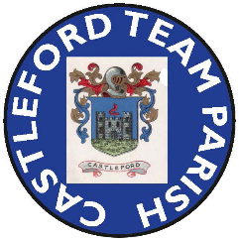
INTERREGNUM NEWSLETTER No. 4
In September 2025 I kept you updated as much as I could of developments during the Interregnum.
Things may have seemed to be quiet since then but a lot of hard work has been going on between the PCC members, the Diocese and Duchy of Lancaster to progress the process to appoint a new Rector.
As I reported previously, the vacancy for a Rector in our Parish was formally advertised on Monday 8th September 2025 with a closing date for applications of 13th October 2025. Following a subsequent interview process I am now able to give the good news that God guided Reverend Kevin Greaves to apply for the position and his appointment as Rector of Castleford has now been approved by the King and Bishop. The Bishop of Wakefield, the Right Reverend Malcolm Chamberlain will licence Reverend Kevin at a service to be held at Castleford Parish Church at 7.30 pm on Thursday 30th April 2026.
I am sure we will give Father Kevin a warm welcome for what is effectively a return to the Parish where he served as curate. His appointment heralds the opening of a new chapter in the life of our Parish and gives fresh impetus to our efforts to grow God’s church in Castleford.
I thank you for your patience and understanding that the selection process had to be treated in total confidence and hope that you feel that the faith and trust you placed in the PCC, Diocese and Duchy to make the right decision has been justified.
As far as church life is concerned, we are continuing to manage to respond to all requests for baptisms and funerals. Reverend Sue Hulme conducted our All Souls service and Christmas masses, Archdeacon Cat Thatcher conducted the Service of Remembrance and we now have clergy led Sunday services scheduled up to the end of April 2026. Particular thanks go to Reverend Sue Hulme, Father Mark Burns and Father Gregory for giving us so much of their time to conduct these services.
I would like to thank everyone, both Clergy and Laity, for all your support through the Interregnum so far and hopefully continued support as we journey through this interesting time.
John Ladley
Lay Chair
4th January 2026

