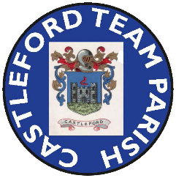
INTERREGNUM NEWSLETTER No. 2

In April I undertook to keep you as informed as I could of developments during the Interregnum.

- I’m sure you all agree that we gave Father Keith and his family a good send off at his last service on 15th June . Thank you to all who contributed to his gifts which I know he, Dee and Luke greatly appreciated. Also thank you to all who organised and contributed to a wonderful buffet spread.

- Final preparations have been made for the coach party who are travelling to Burnopfield on Saturday 5th July to support Father Keith at his licensing in his new Parish and everyone travelling has been given a detailed itinerary.

- The Clergy rota for Sunday Services up to the end of October is now posted on the church notice board. Procedures have been put in place to be able to positively respond to requests for Baptisms, Weddings and Funerals. The PCC is still to make a decision about the Wednesday morning service which is currently temporarily suspended, your views on this are welcome.

- The process for appointing a new rector has formally started. Firstly the PCC has met with the Arch Deacon, Cat Thatcher, to be briefed on what needs to be done, by who and by when. As a result of this meeting a small group of the PCC members are writing a Parish Profile and a Parish Brochure which will be used as part of the recruitment process. As yet I am unable to give any further clarity on when an appointment might be made but rest assured the PCC is working closely with the Diocese and Duchy of Lancaster to find a suitable new Rector in as reasonable time as possible.

As ever, if you have any views on the future of our Parish or have any questions or concerns please do not hesitate to talk to me.

John Ladley
Castleford Team parish
Lay Chair

29th June 2025

